

CS-250: Lab 07
Implementation of Stacks in Different Problems

Muhammad Mujtaba
CMD ID: 540040
mmujtaba.bese25seecs@seecs.edu.pk

  - Class: BESE 16B
  - Batch: 2k25

Stack DS Used:
See stack.hpp.
GitHub Repo Link: https://github.com/mmujtaba25/CS-250
Zip File for only Lab 06: https://github.com/mmujtaba25/CS-250/releases/tag/lab-07

Task 1:
See task1.cpp.
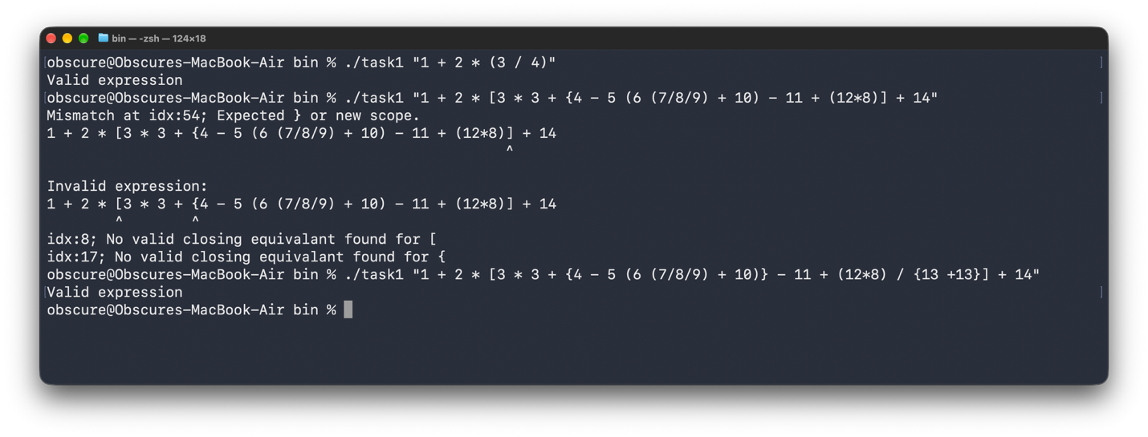
Task Driver:
int main(int argc, char *argv[])
{
if (argc < 2)
{
std::println("Pass in the expression as the first argument when running");
return -1;
}

std::string expression = argv[1];
Stack<std::pair<size_t, char>> brackets_pair;

auto handleClosingBracket = [&brackets_pair, &expression](size_t index, char openingBracket) -> void { //
if (!brackets_pair.isEmpty() && brackets_pair.peek()->second == openingBracket)
brackets_pair.pop();
else
{
std::println("Mismatch at idx:{}; Expected {} or new scope.", index, equivalantBracket(brackets_pair.peek()->second).value());
highlightStackElement(expression, {index});
}
};

for (size_t i = 0; i < expression.size(); i++)
{
const char &c = expression[i];

switch (c)
{
case '(':
case '{':
case '[':
brackets_pair.push(std::make_pair(i, c));
break;
case ')':
case '}':
case ']':
handleClosingBracket(i, equivalantBracket(c).value_or(' '));
break;

// skip any other character
default:
continue;
}
}

if (brackets_pair.isEmpty())
std::println("Valid expression");
else
{
std::println("\nInvalid expression:");
std::vector<size_t> indexes;

for (const auto &[index, bracket] : brackets_pair)
indexes.push_back(index);

highlightStackElement(expression, indexes);

for (int i = indexes.size(); i > 0; i--)
{
size_t index = indexes[i - 1];
std::println("idx:{}; No valid closing equivalant found for {}", index, expression[index]);
}
}

return 0;
}

Task 2:
See task2.cpp.
Part A: task2.cpp#L51
Part B: task2.cpp#L79
Part C: task2.cpp#L118
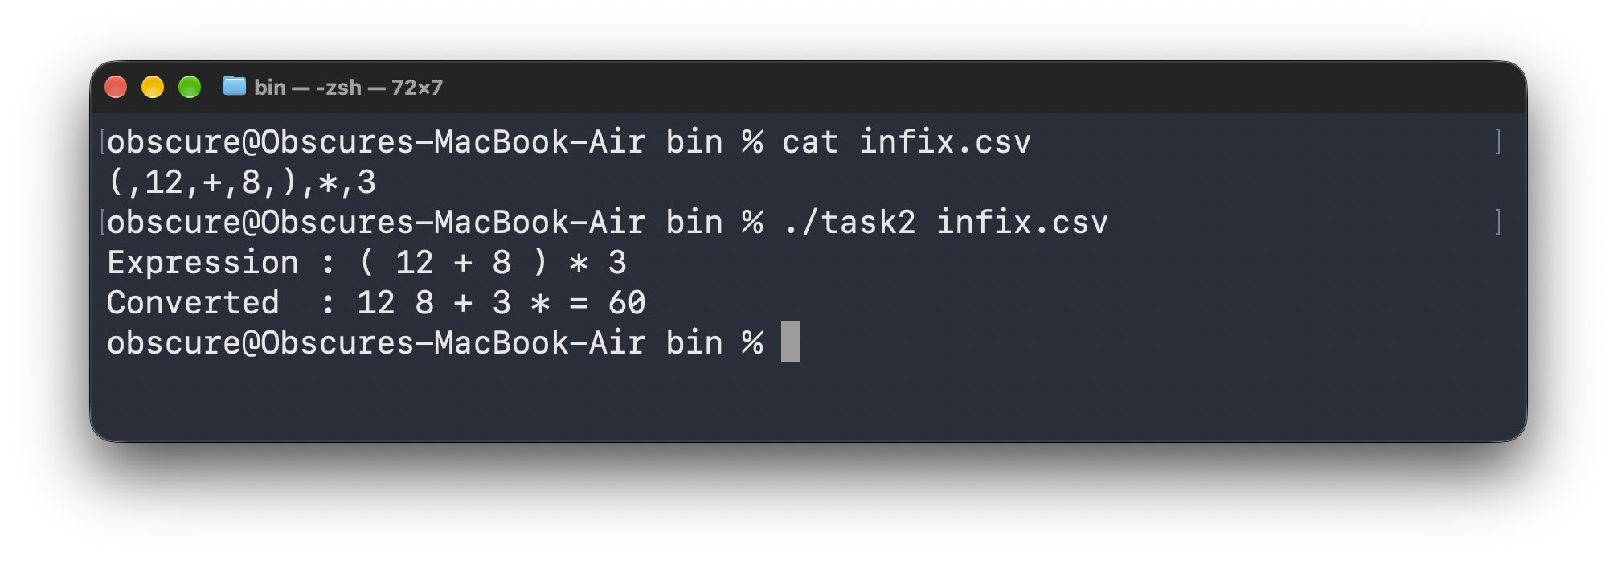
Task Driver:
int main(int argc, char *argv[])
{
if (argc < 2)
{
std::println("Pass in the filename as the first argument when running");
return -1;
}

std::string infixFile = argv[1];

std::vector<std::string> infix = readCSV(infixFile);

std::print("Expression : ");
for (const std::string &token : infix)
{
std::print("{} ", token);
}
std::println();

std::vector<std::string> tokens = infixToPostfix(infix);

std::print("Converted : ");
for (const std::string &token : tokens)
{
std::print("{} ", token);
}
std::print("= {}\n", evaluatePostfix(tokens));

return 0;
}

Task 3:
See task3.cpp.
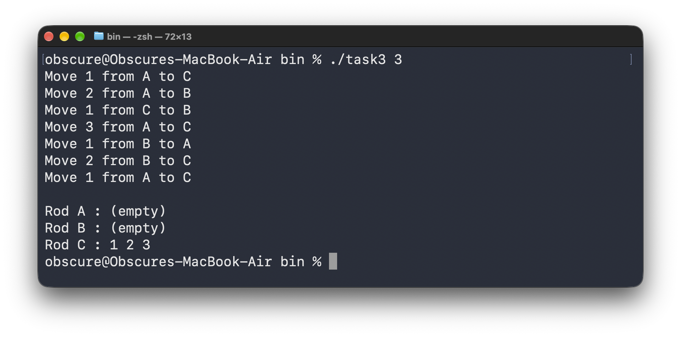
Task Driver:
int main(int argc, char *argv[])
{
if (argc < 2)
{
std::println("Pass in the number of disks as the first argument");
return 1;
}

auto result = isNumber(argv[1]);

if (!result || *result < 1 || *result > 63 ||
*result != static_cast<int>(*result))
{
std::println("Enter a positive integer between 1 and 63");
return 1;
}

int numDisks = static_cast<int>(*result);

Rod rodA{.name = 'A'};
Rod rodB{.name = 'B'};
Rod rodC{.name = 'C'};

// largest disk at the bottom
for (uint8_t disk = numDisks; disk >= 1; --disk)
rodA.disks.push(disk);

towerOfHanoi(numDisks, rodA, rodB, rodC);

std::println();
printRod(rodA, rodA.name);
printRod(rodB, rodB.name);
printRod(rodC, rodC.name);

return 0;
}

